What Is Sumo Robot?
Sumo robot is an electronic device which is consists of a microcontroller ,motor, wheels, leds and RF or IR receivers etc.
Main purpose of sumo robot is improving technical knowledge and also practising as an engineer. There is also funny part of this processis;between universities robot contests are organized by engineering students to prove themselves against other engineering students .

Main Parts Of Sumo Robot
Leading part of this robot is of course microcontroller. We can use many type of microcontroller to control it . We will use PIC16F877 on this robot as a head.
On the other hand there is also software part. Microcontroller needs to be programmed for our purpose. We will give microcontroller ability to control motors , perceiving external world and decide what to do with that information .
Secondly there must be motor controller . Its called L298. Motor controller helps microcontroller to achieve motors driving smoothly and without any lag, hesitation, or distortion.*
Module is DC motor driver using L298. This is most commonly used as driver circuit in hobby robots. This can control 2 DC Motors, their direction using control lines and their speed using PWM. It can Interface it with any microcontroller .
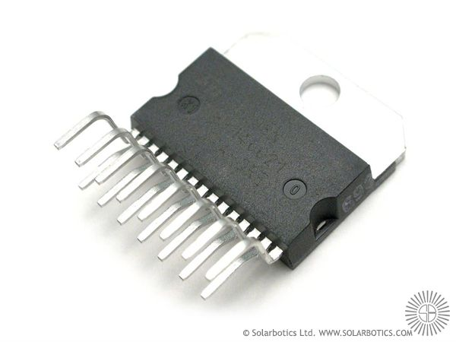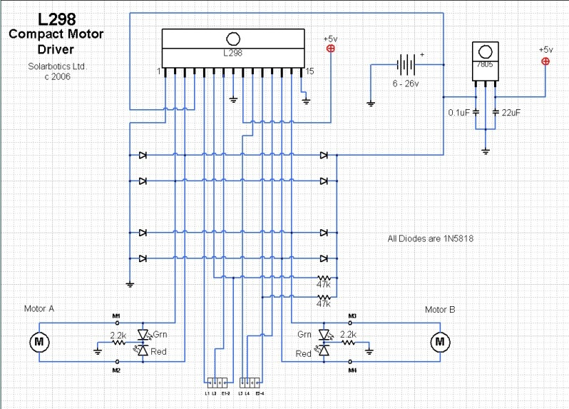
Maximum current rating per channel: 2A
Maximum Supply voltage for Motors: 50V
Maximum Logic Voltage: 7V

Motors are also important. there are mostly 3 types of motors are using in this kind of robotics:
- DC motors
- Servo motors
- Stepper motors
In sumo robot applications, mostly Dc and Servo type motors are preferred. There are pros and cons against each other
A DC motor has a two wire connection. All drive power is supplied over these two wires—think of a light bulb. When you turn on a DC motor, it just starts spinning round and round. Most DC motors are pretty fast, about 5000 RPM (revolutions per minute).
With the DC motor, its speed (or more accurately, its power level) is controlled using a technique named pulse width modulation, or simply PWM. This is idea of controlling the motor’s power level by strobing the power on and off. The key concept here is duty cycle—the percentage of “on time” versus“off time.” If the power is on only 1/2 of the time, the motor runs with 1/2 the power of its full-on operation.
A servo motor is an entirely different story. The servo motor is actually an assembly of four things: a normal DC motor, a gear reduction unit, a position-sensing device (usually a potentiometer—a volume control knob), and a control circuit.
The function of the servo is to receive a control signal that represents a desired output position of the servo shaft, and apply power to its DC motor until its shaft turns to that position. It uses the position-sensing device to determine the rotational position of the shaft, so it knows which way the motor must turn to move the shaft to the commanded position. The shaft typically does not rotate freely round and round like a DC motor, but rather can only turn 200 degrees or so back and forth.The servo has a 3 wire connection: power, ground, and control. The power source must be constantly applied; the servo has its own drive electronics that draw current from the power lead to drive the motor.Contrast this to the DC motor. There are specific motor driver circuits for DC motor. Remember, a DC motor is like a light bulb; it has no electronics of its own and it requires a large amount of drive current to be supplied to it.

7805 5V REGULATOR CIRCUIT

Through the regulator circuit, regulates the power supply.( to filtered 5V)
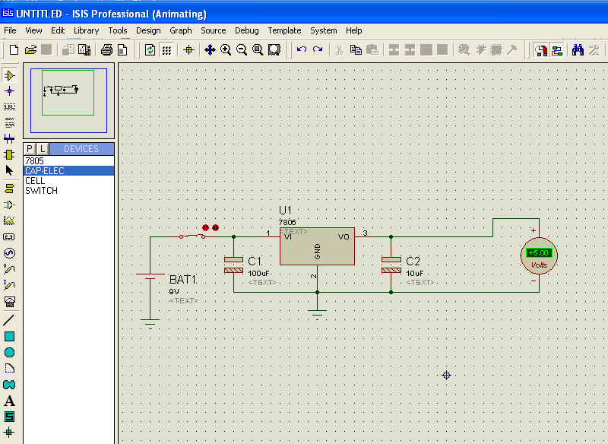

PIC CIRCUIT
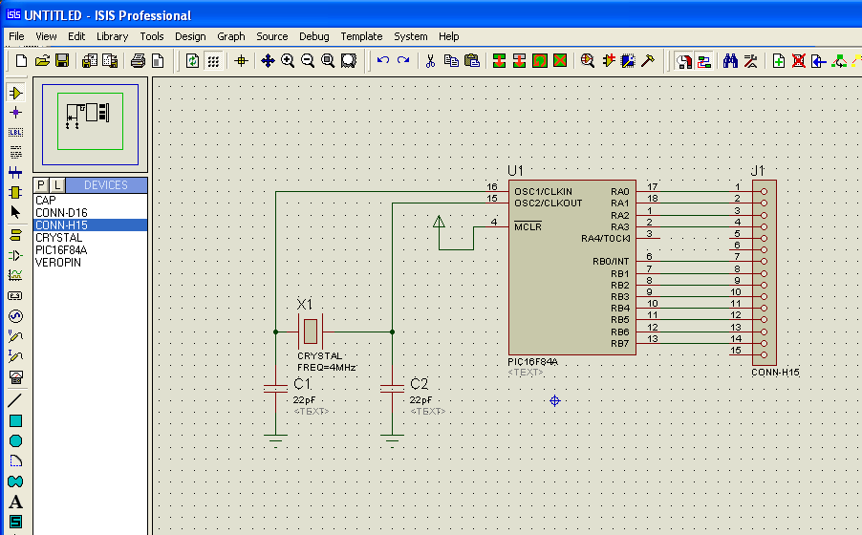
DRIVER CIRCUIT
Current capacity of the one pic is just only 25mA. However , to drive the dc motor we need much bigger current. To improve the signal coming from pic, the driver circuit is needed. Therefore, L298 pic is preferred. L298 has the biggest Imax value between the type of other pics. That Imax value is 3 Ampere.
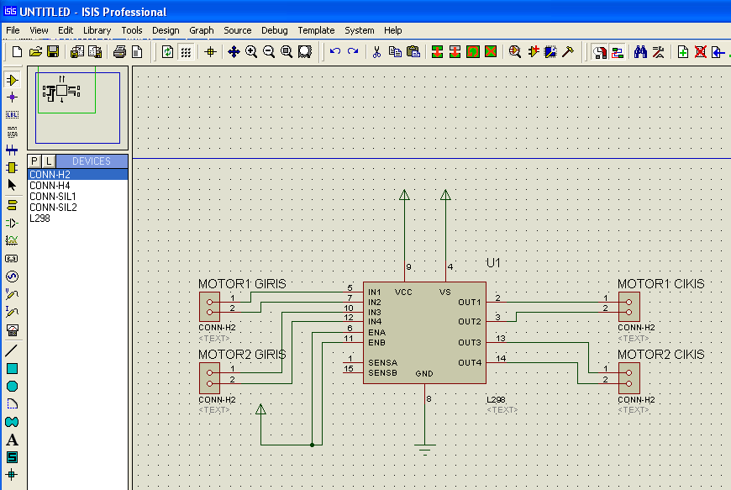
Other pic (L293d) can be preferred for the mini sumo.
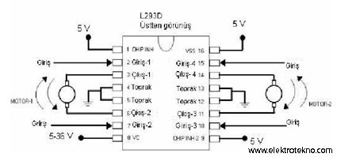
Another representation of the pic circiut:
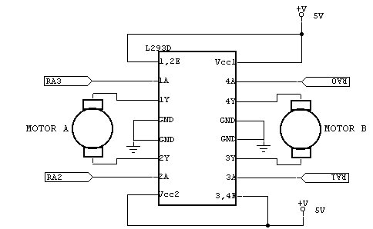
Next step is CNY70 circuit.
CNY70 CIRCUIT
CNY70 is used for stating the white lines. It must be very sensitive. For more information look at the data sheet of the CNY70
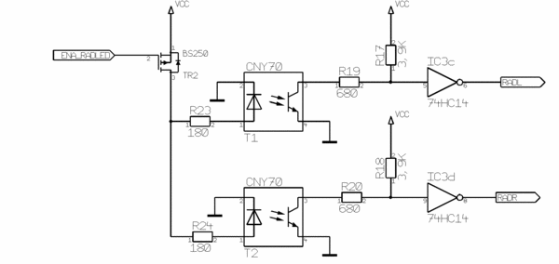

Sensor Systems
2 type of sensors are used in sumo robot first one helps robot not to go out off arena. Arena is shaped as circle. Sumo fighting arena consist of two types of color; the edge color is white which surrounds the arena as 5 cm width . Inner place of the white circle is black for the maximum contrast. For this reason we need to use CN70 contrast sensor.
CN70 is a sensor that based on a led and fototransistor cooperation.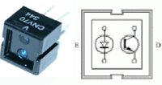

Led sends a signal to the ground signal reflectsfrom it and fototransistor turn on or turn off according to reflected signal.
Second type of sensors that we can call them as robot target sensors which are seperated into 3 subgroups;
1.touching key
2. ultrasonic object sensors
3. Infrared object sensors (proximity sensors)
1. Touching keys are basic elements that work like a button for general purpose.it can be usefull when pushing or running from opponent robot. And also gives the robot extra sense.
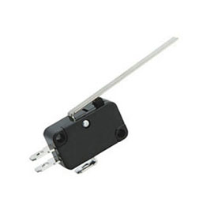
a touch key sensors

2.Ultrasonic object sensors creates sound waves (figxxx) .It sends sound around itself and gather it again which has 40 khz pulse timing. The sensor works accordingly the reflected sound from surrounding objects as an existance of reflected waves or amplitude of gathered wave .
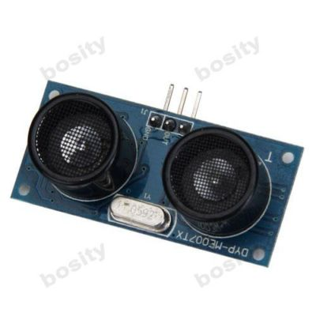
ultrasonic object sensors,
3.Third sensor type is Infrared object sensors its similar like proximity sensors . this sensor type has similar logic with the other sensors that we have explained above . It uses ınfrared light and can measure the distance between object and itself . It is easy to build a receiver and transmitter systems but we can also use pre-ready systems instead, for more ergonomic design and stable communication.
In sumo robot circuits designers are generally use SHARP GP2D IR systems. it is easy to drive from microcontroller. This kind of proximity sensors put forward the distance data or according to existance of the target in sensor range , create a signal as an analog or digital. When the sensor is triggered 8-bits of digital distance data is presented by the sensor .
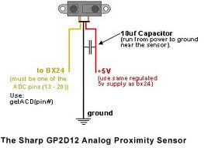
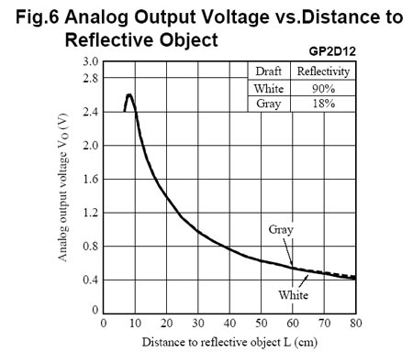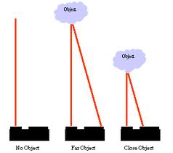
Here is the general sharp GP2D02 connections;
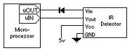
It has 4 pin connection which are Vin,Vout,GND and 5 volts gp2d02 proximity sensor has stationary phase that is high voltage (1) . Microcontroller puts down the voltage to low (1 to 0) for turning on the sensor. When this is happened: the Vout voltage of the sensor goes down to 0 logic state. This means that sensor is starts working. After that, sensor gathers the data and send when the data is ready to send to microcontroller, it makes Vout pin high voltage logic (1) and then Vin goes logic 1 and sensor transfers the data as 8-bit, via Vout pin.

